From downturn to upswing: Strong fourth-quarter returns in stocks and bonds

Expert Perspective
December 29, 2023

Francis M. Kinniry Jr., CFA
Head of Investment Advisory Research Center

Ted Dinucci, CFA
Senior Research Specialist, Investment Advisory Research Center

Chris Tidmore, CFA
Senior Manager, Investment Advisory Research Center

The final two months of 2023 witnessed impressive surges in both the equity and bond markets, with increases of approximately 15% and 8%, respectively.¹ These gains contributed to year-to-date returns of 25% and 5% for the equity and bond markets, respectively. It is worth noting that these returns followed significant sell-offs in both markets over the prior few months. This pattern of fluctuating markets is a common occurrence that investors often experience throughout their investing journey.
The unpredictable nature of the markets, characterized by clusters of upward and downward swings, intersects with investors' rational behaviors such as loss aversion, regret, and the fear of missing out (FOMO). Emotions like regret and loss aversion often influence timing decisions, leading investors to sell out when losses occur, which may seem intuitive and appealing. However, it is important to recognize that these decisions can be detrimental, as strong bull market recoveries often follow, leading to subsequent regret and FOMO.

Don’t overlook the role of emotional and behavioral fortitude
As we have learned repeatedly, emotional and behavioral fortitude can be just as crucial, if not more so, than the specific portfolio in which clients invest. Previous analysis and blogs have demonstrated the risks associated with attempting to time the equity and fixed income markets to avoid downturns and capture the best days, months, and quarters. This is challenging because of the tendency for both positive and negative market movements to cluster together, a phenomenon also observed in the fixed income market.
It is worth highlighting that the equity market has now fully recovered on a total return basis from the declines experienced in 2022, reaching all-time highs. Additionally, the 8% return in the bond markets over the past eight weeks ranks among some of the strongest bond market performances for comparable time frames.
The journey to reaching new all-time highs in the equity market has been far from smooth and unexpected by most. It has been characterized by strong oscillating moves, which, although normal, have not followed a linear trajectory. The figure below illustrates the monthly returns of stocks and bonds, showcasing their non-linear and oscillating nature. Despite the ups and downs, when compounded together, these returns have resulted in robust year-to-date performance.

Figure 1: Roller coaster of a year ending with an incredible rally during the fourth quarter
a) Cumulative 2023 return for stocks by month
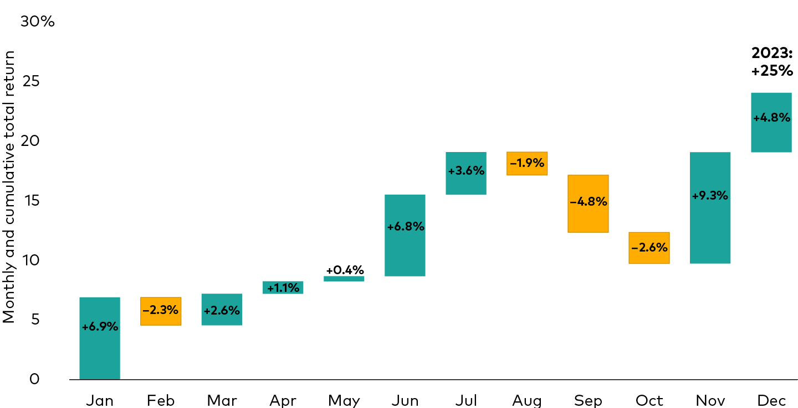

b) Cumulative 2023 return for bonds by month
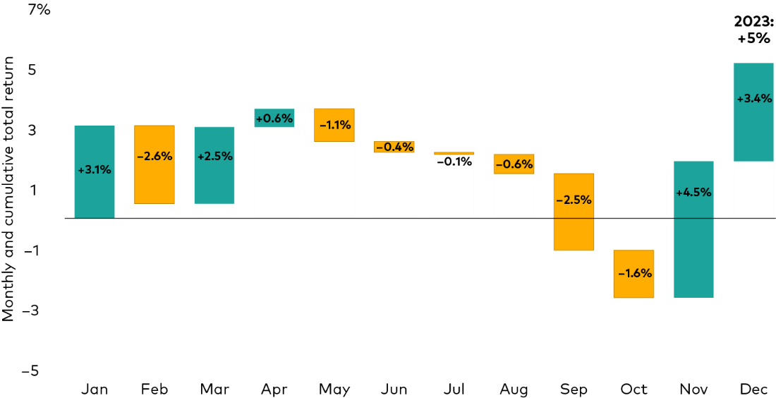

Notes: Figures 1a and 1b show the cumulative performance, by month, from January 1st through December 21, 2023.
Sources: Investment Advisory Research Center analysis using data from Morningstar, Inc. Figure 1a, stocks: CRSP US Total Market Index. Figure 1b, bonds: Bloomberg U.S. Aggregate Bond Index.

Past performance is no guarantee of future results. The performance of an index is not an exact representation of any particular investment, as you cannot invest directly in an index.

Equity concentration: Not a new phenomenon
Where did these impressive returns come from? It is worth noting that there is abundant news coverage highlighting the role of only a handful of stocks in driving the quarterly and yearly rally in the stock markets. These stocks called the “Magnificent 8” include Amazon, Apple, Microsoft, Nvidia, Alphabet (Google), Meta (Facebook), Netflix, and Tesla. For the quarter and year, the Magnificent 8 returns were 14% and 77%, respectively, while the S&P 500 returns excluding the Magnificent 8 for the quarter and year were 9% and 10%, respectively.² Importantly, this phenomenon is not new. In fact, as we can see below, a historical analysis reveals that a significant portion of the market's returns can be attributed to a small percentage of the thousands of stocks that have existed. Even when we exclude the recent mega-cap tech growth boom over the last 10 years, we find that a small percentage of stocks still explains much of the market’s historical returns.
For instance, as illustrated in the chart below, it becomes evident that throughout history, only a mere 72 companies out of the thousands of publicly traded companies have accounted for half of the total returns. This highlights the concentrated nature of market performance, where a select few companies play a significant role in driving overall returns.

Figure 2: Equity concentration isn’t new—a small percentage of U.S. stocks have produced much of the markets’ historical returns
Number of firms that explain fractions of market returns
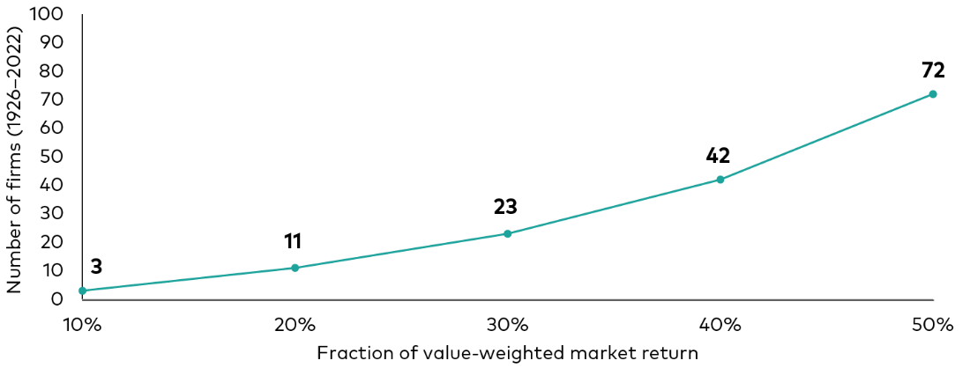

Notes: Calculations based on total asset-weighted returns of individual U.S. publicly traded stocks as a percentage of total U.S. asset-weighted returns from all publicly traded U.S. stocks.

Sources: Investment Advisory Research Center analysis using data from Shareholder Wealth Enhancement, Bessembinder (2023)

Past performance is no guarantee of future results. The performance of an index is not an exact representation of any particular investment, as you cannot invest directly in an index.

The power of “staying the course”
In 2022, we introduced a series of “we are here” illustrations to highlight the historically poor quarterly returns of both stocks and bonds during that period. However, in the five quarters since those challenging times, these same illustrations now demonstrate the power of "staying the course.” They showcase how the markets have rebounded strongly, emphasizing the importance of maintaining a long-term investment strategy and not succumbing to short-term market fluctuations.

Figure 4a: Distribution of annual stock performance (1928–2023)
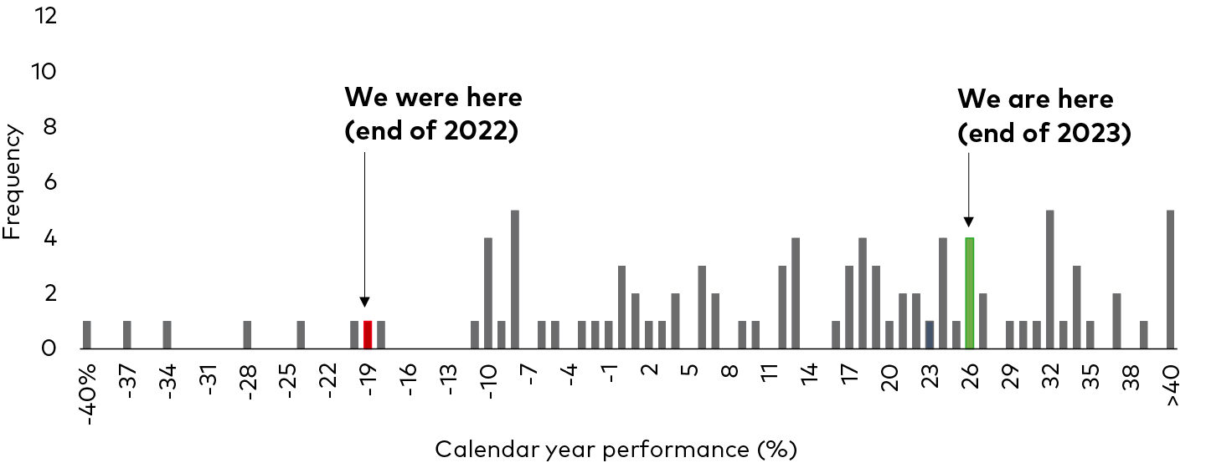

Figure 4b: Distribution of annual bond performance (1928—2023)
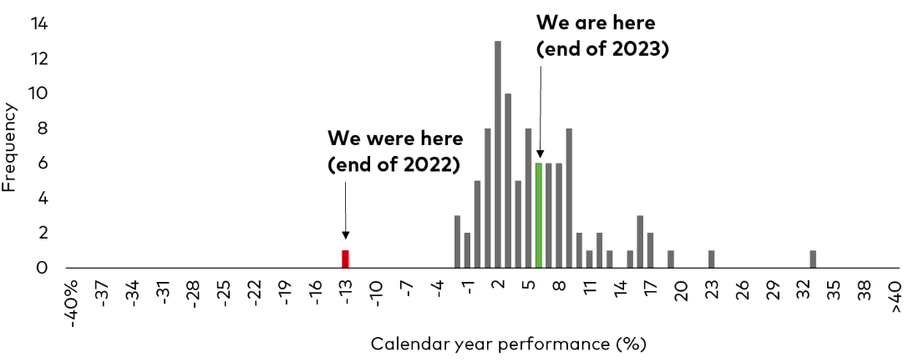

Figure 4c: Distribution of annual 60/40 performance (1928—2023)
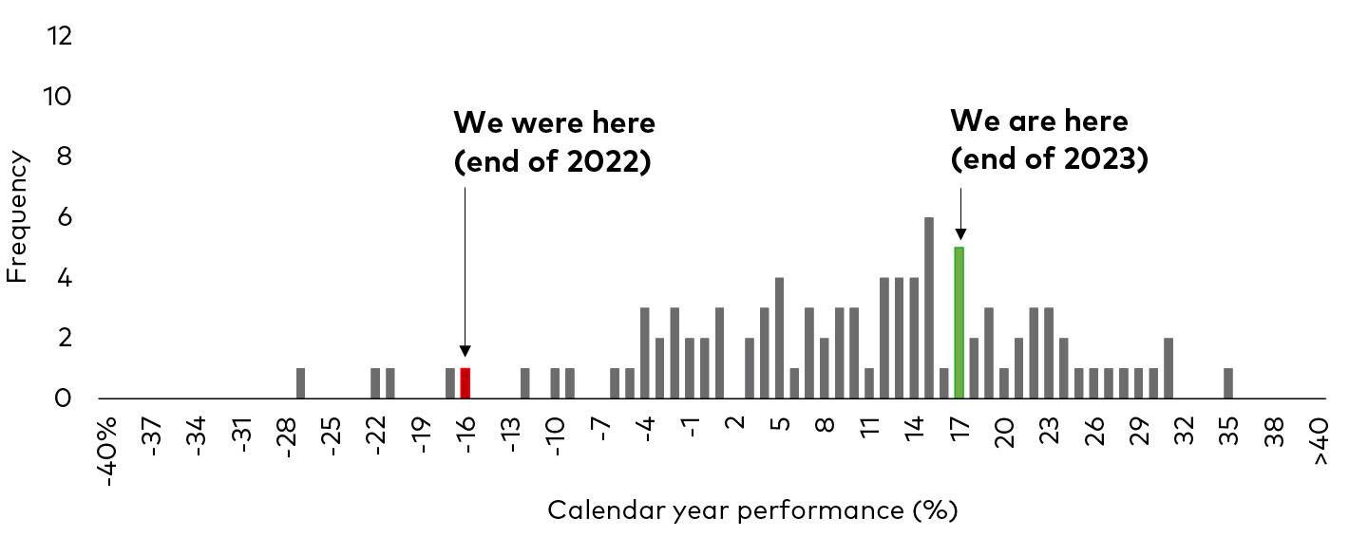

Notes: Figures 4a, 4b, and 4c show the cumulative performance from January through December each calendar year going back to 1928. Data for 2023 performance is through December 21, 2023.
Sources: Investment Advisory Research Center analysis using data from Morningstar, Inc. Figures 4a to 4c.: Stocks: S&P 90 Index from 1928 through March 3,1957; S&P 500 Index from March 4, 1957 through 1970; Wilshire 5000 from 1971 through April 22, 2005; MSCI US Broad Market Index through June 2, 2013; CRSP US Total Market Index thereafter. Bonds: IA SBBI U.S. Intermediate-Term Government Bond Index through 1972; Bloomberg U.S. Government/Credit Intermediate-Term Index from 1973 through 1975; Bloomberg U.S. Aggregate Bond Index thereafter. 60/40: Simulated portfolio with 60% allocated to stocks and 40% allocated to bonds.

Past performance is no guarantee of future results. The performance of an index is not an exact representation of any particular investment, as you cannot invest directly in an index.

1 Through December 21, 2023.
2 FactSet data, through December 21, 2023.

Notes:
All investing is subject to risk, including possible loss of principal.
Be aware that fluctuations in the financial markets and other factors may cause declines in the value of your account. There is no guarantee that any particular asset allocation or mix of funds will meet your investment objectives or provide you with a given level of income. Diversification does not ensure a profit or protect against a loss. Past performance is not a guarantee of future results.
Bond funds are subject to the risk that an issuer will fail to make payments on time, and that bond prices will decline because of rising interest rates or negative perceptions of an issuer's ability to make payments.

